HERO POS module database internal setup during installation

**Table pos_configs**

1. Import the pos configurations
2. Open browser and go to URL : http://localhost/phpmyadmin
3. Choose the database “gm4g_pos”
4. Choose the table “pos_configs”
5. Click the import tab  to import data using provided SQL script
6. Choose the file “pos_configs.sql” for importing and press “Go”

The following are the record’s information for reference

**Please note that the value scfg_value should changed according to the server needed**

Record for kitchen slip (kichenSlipPath and kichenSlipURLPath)

*Kitchen Slip Path*

|  |  |
| --- | --- |
| **Field Name** | **Value** |
| scfg_id | ** No need to input as it will be generated automatically |
| scfg_by | kitchen_slip |
| scfg_record_id | 0 |
| scfg_section | printing |
| scfg_variable | kichenSlipPath |
| scfg_index | 0 |
| scfg_value | C:\MyWeb\gm4g_demo_files\data\print_jobs\ |
| scfg_remark |  |
| created | ** current time date |
| modified | ** set it to NULL |

*Kitchen Slip URL Path*

|  |  |
| --- | --- |
| **Field Name** | **Value** |
| scfg_id | ** No need to input as it will be generated automatically |
| scfg_by | kitchen_slip |
| scfg_record_id | 0 |
| scfg_section | printing |
| scfg_variable | kichenSlipURLPath |
| scfg_index | 0 |
| scfg_value | /files/data/print_jobs/ |
| scfg_remark |  |
| created | ** current time date |
| modified | ** set it to NULL |

Record for kitchen slip (checkSlipPath and checkSlipURLPath)

*Check Slip Path*

|  |  |
| --- | --- |
| **Field Name** | **Value** |
| scfg_id | ** No need to input as it will be generated automatically |
| scfg_by | check_slip |
| scfg_record_id | 0 |
| scfg_section | printing |
| scfg_variable | checkSlipPath |
| scfg_index | 0 |
| scfg_value | C:\MyWeb\gm4g_demo_files\data\print_jobs\ |
| scfg_remark |  |
| created | ** current time date |
| modified | ** set it to NULL |

*Check Slip URL Path*

|  |  |
| --- | --- |
| **Field Name** | **Value** |
| scfg_id | ** No need to input as it will be generated automatically |
| scfg_by | check_slip |
| scfg_record_id | 0 |
| scfg_section | printing |
| scfg_variable | checkSlipURLPath |
| scfg_index | 0 |
| scfg_value | /files/data/print_jobs/ |
| scfg_remark |  |
| created | ** current time date |
| modified | ** set it to NULL |

Record for kitchen slip (specialSlipPath and specialSlipURLPath)

*Special Slip Path*

|  |  |
| --- | --- |
| **Field Name** | **Value** |
| scfg_id | ** No need to input as it will be generated automatically |
| scfg_by | special_slip |
| scfg_record_id | 0 |
| scfg_section | printing |
| scfg_variable | specialSlipPath |
| scfg_index | 0 |
| scfg_value | C:\MyWeb\gm4g_demo_files\data\print_jobs\ |
| scfg_remark |  |
| created | ** current time date |
| modified | ** set it to NULL |

*Check Slip URL Path*

|  |  |
| --- | --- |
| **Field Name** | **Value** |
| scfg_id | ** No need to input as it will be generated automatically |
| scfg_by | special_slip |
| scfg_record_id | 0 |
| scfg_section | printing |
| scfg_variable | specialSlipURLPath |
| scfg_index | 0 |
| scfg_value | /files/data/print_jobs/ |
| scfg_remark |  |
| created | ** current time date |
| modified | ** set it to NULL |

*Interface URL Path*

|  |  |
| --- | --- |
| **Field Name** | **Value** |
| scfg_id | ** No need to input as it will be generated automatically |
| scfg_by | applicationUI |
| scfg_record_id | 0 |
| scfg_section | posSystem |
| scfg_variable | interfaceURLPath |
| scfg_index | 0 |
| scfg_value | http://<corresponding IP address>/gm4g_server/ |
| scfg_remark |  |
| created | ** current time date |
| modified | ** set it to NULL |

1. Revise the interface URL path
2. Open browser and go to URL : http://localhost/phpmyadmin
3. Choose the database “gm4g_pos”
4. Choose the table “pos_configs”
5. Go to search tab  and input the following searching criteria and then press “Go”

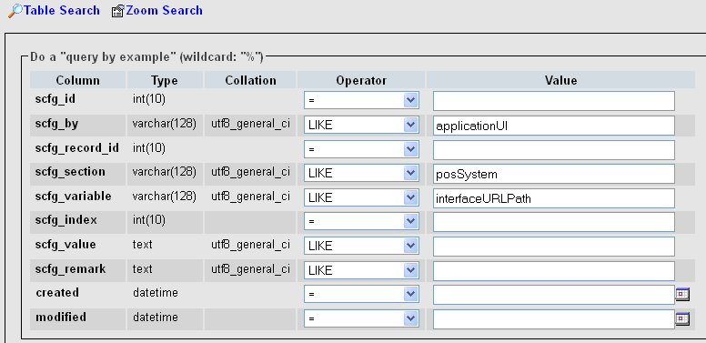

1. A record will be shown and change the scfg_value to the following:

http://<IP Address>/gm4g_server/

1. Revise the printing path and URL path (**If necessary**)
2. Go to database admin page

For example: <http://192.168.99.40/phpmyadmin/index.php>

1. Choose the database “gm4g_pos”
2. Choose the table “pos_configs”
3. Choose the corresponding needed record and only change the value of ‘scfg_value’

**Table pos_functions**

1. Import pos supported function list
2. Open browser and go to URL : http://localhost/phpmyadmin
3. Choose the database “gm4g_pos”
4. Choose the table “pos_functions”
5. Click the import tab  to import data using provided SQL script
6. Choose the file “pos_functions.sql” for importing and press “Go”